

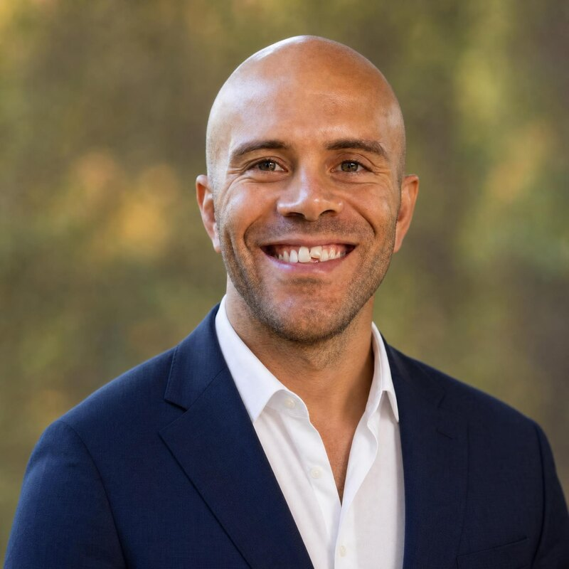  Simba Stenqvist  Somatic Practitioner & TRE® Specialist  CONTACT  Team  BHD Asia  Based  Chiang Mai & across Asia  E-mail  isabelle@bhdasia.com  Web  bhdasia.com  FOCUS AREAS  ▪ Nervous-System Regulation  ▪ TRE® & Tremor Work  ▪ Bodywork & Fascia  ▪ Breathwork  ▪ Detox & Nutrition  ▪ Mindfulness  ▪ Family Wellbeing  AT A GLANCE  ▪ 25+ years of practice  ▪ Trained with Dr. David Berceli (TRE®)  ▪ Teaches across Singapore, Indonesia & Thailand | "The nervous system is the foundation for clarity, presence, and steady decision-making under pressure."  Profile  Part of the BHD Asia team, Simba Stenqvist brings more than twenty-five years of hands-on practice in bodywork, nervous-system regulation, and energetic healing into one integrated approach — developed in close collaboration with Dr. David Berceli, founder of TRE® (Tension & Trauma Release Exercises).  His work is grounded in anatomy, physiology, and nervous-system science, with each session shaped around what the body in front of him actually needs. Simba teaches and delivers this work across Singapore, Indonesia, Thailand and internationally — working with practitioners, leaders, and high-performing individuals who are technically excellent yet privately sense a ceiling that more knowledge hasn't been able to move.  How Simba Supports You  • Stress Reduction & Emotional Regulation — Working directly with tension held in the body to bring the nervous system back to presence and calm.  • Pain Recovery & Physical Wellbeing — Reading muscular tension and chronic discomfort as fascial patterns, restoring circulation and mobility.  • Sleep & Recovery — Restoring the deep rest the nervous system needs, so energy and resilience return on their own.  • Detoxification & Organ Health — Working with the fascia around the organs directly, so digestion, immunity and energy improve naturally.  • Mindfulness & Mental Clarity — Simple, repeatable practices that bring the mind back to calm awareness — for adults and children alike.  • Family Health & Lifestyle Balance — Helping families build shared rhythms of movement, nourishment and rest that continue long after a retreat ends.  Modalities  • Internal Alchemy — An integrated system combining breathwork, fascial release, grounding and tremor work — restoring the nervous system at the level where tension actually lives.  • TRE® — A safe, natural method that lets the body release stress and tension through its own tremor response.  • Breathwork — Guided breathing that shifts oxygen flow and nervous-system state, changing energy, focus and emotional regulation.  • Bodywork & Structural Therapy — Sessions built around chronic pain, muscular imbalance and injury, shaped to the body in front of him.  • Chi Nei Tsang — A Taoist abdominal-organ technique supporting digestion and the emotional weight the organs quietly hold.  • NADA AcuDetox — A gentle ear-acupuncture protocol supporting the nervous system's own detoxification and stress release.  • Fascia Therapy — Manual and movement-based techniques that release tension in the connective tissue shaping posture, mobility and organ health.  • Mindfulness & Meditation — Simple guided practices that return you to inner focus, calm and connection.  Ways to Work Together  • Private Sessions — 1-on-1 sessions shaped entirely around your needs — whether pain relief, stress, or deep rest.  • Couple & Family Sessions — Shared sessions that bring the family together through movement and mindfulness.  • Group Workshops — Interactive sessions introducing foundational practices suitable for every age.  • Lifestyle Programs — Immersive experiences combining habits, nutrition, movement and rest that reset patterns for good.  • Online Follow-Up Support — Continued guidance after you return home, to hold onto what shifted and keep growing.  Approach  Simba's approach is direct and grounded. He works with the body itself to release stress, improve circulation, and restore balance in the nervous system. These are tools anyone can access, regardless of background — and they show up as better sleep, more energy, emotional steadiness, and closer connection. Each session meets you where you are: physically, emotionally, and culturally.

